A Project report on
Video Analytics–Based Traffic Control Using YOLO and RCNN for Smart Traffic Management

Submitted in partial fulfilment of the requirements
for the award of the degree of

BACHELOR OF TECHNOLOGY
in

COMPUTER SCIENCE AND ENGINEERING

(ARTIFICIAL INTELLIGENCE & MACHINE LEARNING)

By
V. SARVAGNA (224G1A3397)
S. ROOPA (224G1A3383)
B. THEJA (234G5A3310)
Y. CHANDRA KUMAR (234G5A3301)

Under the Guidance of

Mr. K. Kondanna M.Tech.,(Ph.D.)

Department of Computer Science and Engineering
(Artificial Intelligence & Machine Learning)

Srinivasa Ramanujan Institute of TECHNOLOGY (AUTONOMOUS)
Rotarypuram Village, B K Samudram Mandal, Ananthapuramu - 515701
2025-2026
SRINIVASA RAMANUJAN INSTITUTE OF TECHNOLOGY
(AUTONOMOUS)
(Affiliated to JNTUA, Accredited by NAAC with ‘A’ Grade, Approved by AICTE, New Delhi & Accredited by NBA (CIV, EEE, MEC, ECE & CSE)
Rotarypuram Village, BK Samudram Mandal, Ananthapuramu-515701

Department of Computer Science and Engineering
(Artificial Intelligence & Machine Learning)

=

Certificate
This is to certify that the project report entitled Video Analytics–Based Traffic Control Using YOLO and RCNN for Smart Traffic Management is the bonafide work carried out by V. Sarvagna, S. Roopa, B. Theja, Y. Chandra Kumar bearing Roll Number 224G1A3397, 224G1A3383, 234G5A3310, 234G5A3301 in partial fulfilment of the requirements for the award of the degree of Bachelor of Technology in Computer Science and Engineering (Artificial Intelligence & Machine Learning) during the academic year 2025-2026.

Project Guide Head of the Department
Mr. K. Kondanna, _{M.Tech.,(Ph.D.)} Dr. P. Chitralingappa, _{M.Tech.,Ph.D.}
Assistant Professor Associate Professor

Date: External Examiner
Place: Rotarypuram

DECLARATION CERTIFICATE
We students of Computer Science and Engineering (AI & ML), SRINIVASA RAMANUJAN INSTITUTE OF TECHNOLOGY(AUTONOMOUS), Rotarypuram, hereby declare that the dissertation entitled Video Analytics–Based Traffic Control Using YOLO and RCNN for Smart Traffic Management embodies the report of our project work carried out by us during IV year under the guidance of Mr. K. Kondanna _{M.Tech.,(Ph.D.)}, Assistant Professor, Department of Computer Science and Engineering (AI & ML), Srinivasa Ramanujan Institute of Technology, and this work has been submitted for the partial fulfillment of the requirements for the award of degree of Bachelor of Technology.
The results embodied in this project report have not been submitted to any other University or Institute for the award of any Degree or Diploma.

Date:
Place:
S.No. | Name of the Student | Roll Number | Signature
1 | V. SARVAGNA | 224G1A3397
2 | S. ROOPA | 224G1A3383
3 | B. THEJA | 234G5A3310
4 | Y. CHANDRA KUMAR | 234G5A3301

Vision & Mission of the SRIT
Vision:
To become a premier Educational Institution in India offering the best teaching and learning environment for our students that will enable them to become complete individuals with professional competency, human touch, ethical values, service motto, and a strong sense of responsibility towards environment and society at large.

Mission:
- Continually enhance the quality of physical infrastructure and human resources to evolve in to a center of excellence in engineering education.
- Provide comprehensive learning experiences that are conducive for the students to acquire professional competences, ethical values, life-long learning abilities and understanding of the technology, environment and society.
- Strengthen industry institute interactions to enable the students work on realistic problems and acquire the ability to face the ever changing requirements of the industry.
- Continually enhance the quality of the relationship between students and faculty which is a key to the development of an exciting and rewarding learning environment in the college.

Vision & Mission of the Department of CSE (AI & ML)
Vision:

To evolve as a leading department by offering best comprehensive teaching and learning practices for students to be self-competent technocrats with professional ethics and social responsibilities.

Mission:

DM 1: Continuous enhancement of the teaching-learning practices to gain profound knowledge in theoretical & practical aspects of computer science applications.

DM 2: Administer training on emerging technologies and motivate the students to inculcate self-learning abilities, ethical values and social consciousness to become competent professionals.

DM 3: Perpetual elevation of Industry-Institute interactions to facilitate the students to work on real-time problems to serve the needs of the society.
Program Educational Objectives (PEOs)
An SRIT graduate in Computer Science & Engineering, after three to four years of graduation will:
PEO 1: Lead a successful professional career in IT / ITES industry / Government organizations with ethical values.
PEO 2: Become competent and responsible computer science professional with good communication skills and leadership qualities to respond and contribute significantly for the benefit of society at large.
PEO 3: Engage in life-long learning, acquiring new and relevant professional competencies / higher academic qualifications.

ACKNOWLEDGEMENT

The satisfaction and euphoria that accompany the successful completion of any task would be incomplete without the mention of people who made it possible, whose constant guidance and encouragement crowned our efforts with success. It is a pleasant aspect that I have now the opportunity to express my gratitude for all of them.

It is with immense pleasure that I would like to express my indebted gratitude to my project coordinator Mr. K. Kondanna, Assistant Professor, Department of Computer Science and Engineering ( AI & ML ), who has supported me a lot and encouraged me in every step of the project work. I thank him for the stimulating support, constant encouragement and constructive criticism which have made possible to bring out this internship work.

I am very much thankful to Dr. P. Chitralingappa, Associate Professor & HOD, Computer Science and Engineering ( AI & ML ), for his kind support and for providing necessary facilities to carry out the work.

I wish to convey my special thanks to Dr. G. Balakrishna, Principal of Srinivasa Ramanujan Institute of Technology (Autonomous) for giving the required information in doing my internship. Not to forget, I thank all other faculty and non-teaching staff, and my friends who had directly or indirectly helped and supported me in completing my internship in time.

I also express our sincere thanks to the Management for providing excellent facilities and support.

Finally, I wish to convey my gratitude to my family who fostered all the requirements
and facilities that I need.
Project Associates
224G1A3397
224G1A3383
234G5A3310
234G5A3301

Video Analytics–Based Traffic Control Using YOLO and RCNN for Smart Traffic Management

ABSTRACT
In urban areas, efficient traffic management is essential for minimizing delays and enhancing emergency response times. This project introduces a machine learning-based approach for intelligent traffic management at four-way signals, focusing on emergency vehicle identification and prioritization. The methodology involves several steps: identifying emergency vehicles using YOLOv8 and RCNN techniques on video data, counting and categorizing all vehicles at the intersection, and analyzing the videos to predict the optimal time required to clear traffic. Utilizing a video database from COCO, the system processes inputs to detect emergency vehicles and provides real-time alerts to prioritize their passage. If an emergency vehicle is identified, a message displays the vehicle's location and clears the route promptly. When no emergency vehicles are present, the system estimates the time needed to clear the intersection based on the total vehicle count, optimizing traffic flow. This approach balances routine traffic management with emergency response needs, aiming to reduce congestion and enhance overall traffic efficiency. The results indicate that intelligent traffic management using advanced techniques can significantly improve urban mobility and emergency response capabilities.

Keywords: Intelligent Traffic Management, Machine Learning, YOLOv8, RCNN, Emergency Vehicle Identification, Video Analysis, COCO Database, Traffic Optimization, Urban Mobility, Real-time Alerts.

PROJECT CONTRIBUTION TOWARDS
SUSTAINABLE DEVELOPMENT GOALS
Project Title:
Video Analytics–Based Traffic Control Using YOLO and RCNN for Smart Traffic Management
SDG - Project Mapping:
S.No. | Sustainable Development Goals | Mapped  (Yes/No)
1 | SDG 1: No Poverty | No
2 | SDG 2: Zero Hunger | No
3 | SDG 3: Good Health and Well-Being | Yes
4 | SDG 4: Quality Education | No
5 | SDG 5: Gender Equality | No
6 | SDG 6: Clean Water and Sanitation | No
7 | SDG 7: Affordable and Clean Energy | No
8 | SDG 8: Decent Work and Economic Growth | Yes
9 | SDG 9: Industry Innovation and Infrastructure | Yes
10 | SDG 10: Reduced Inequalities | No
11 | SDG 11: Sustainable Cities and Communities | Yes
12 | SDG 12: Responsible Consumption and Production | No
13 | SDG 13: Climate Action | Yes
14 | SDG 14: Life Below Water | No
15 | SDG 15: Life on Land | No
16 | SDG 16: Peace Justice and Strong Institutions | Yes
17 | SDG 17: Partnerships for the Goals | No
Explanation:
- The project improves emergency response time by prioritizing ambulances and fire vehicles, helping save lives (SDG 3).
- It supports smart infrastructure development using AI and machine learning technologies (SDG 9 & SDG 11).
- Optimized traffic flow reduces congestion, fuel consumption, and emissions, improving environmental sustainability and road safety (SDG 13 & SDG 16).
Expected Impact:
Parameter | Impact
Emergency Response Time | Reduced by 20–40%
Traffic Congestion | Decreased significantly in peak hours
Fuel Consumption | Reduced due to smoother traffic flow

CONTENTS

 | Page No.
List of Figures | XII
List of Tables | XIII
Abbreviations | XIV
- Introduction  - Motivation  - Problem Statement  - Objective of the Project  - Scope  - Project Introduction | 1 - 3  1  1  1  2  2
- Literature Survey | 4 - 5
- System Analysis  - Existing System  3.1.1. Disadvantages  - Proposed System  3.2.1. Advantages | 6 – 8  6  6  7  7
- Requirement Analysis  - Functional Requirements  - Non Functional Requirements  - Software Requirements  - Architecture | 9 – 13  9  10  12  13
- Algorithms  - YOLOv8 for Traffic Management  - Introduction to YOLO8  - Data Preparation and Annotation  - Model Training  - Real-Time Vehicle Detection  - Vehicle Classification and Prioritization  - System Integration and Testing  - Performance Evaluation and Optimization  - Conclusion  - RCNN for Traffic Management  - Introduction to RCNN  - Data Preparation and Annotation  - Model Training  - Model Evaluation and Fine-Tunning  - Integration into Traffic Management System  - Challenges and Considerations | 14 – 19  14  14  14  15  15  16  16  16  17  17  17  17  18  18  18  19
- System Design  - System Architecture Overview  - System Modules and Design Flow  - Data Collection and Preprocessing  - Vehicle Detection and Classification  - Traffic Flow Prediction and Optimization  - Emergency Vehicle Prioritization  - Real-Time Alerts and Visualization  - User Interface and Visualization  - System Workflow  - Technology and Tools  - Diagrams  - UML Diagram  - Use Case Diagram  - Class Diagram  - Sequence Diagram  - Collaboration Diagram  - Deployment Diagram  - Activity Diagram  - Component Diagram  - ER Diagram  - Data Flow Diagram | 20 - 30  20  20  20  20  21  21  22  22  23  23  24  24  24  25  26  26  27  27  28  29  29
- Implementation and Results  - Modules  - System  - User  - Output Screens  - Upload Screen  - Processing Screen  - Result Screen | 31 – 33  31  31  32  32  32  33  33
- System Study and Testing  - System Overview  - Data Collection  - Data Preprocessing  - Feature Selection  - Model Development | 34 – 36  34  34  34  35  35
Future Enhancement | 37
Conclusion | 38
References | 39 - 40
Publications related to project | 41
Project CO-PO Mapping | 42
Internship Certificates | 43 - 46
Details of Project Team | 47

LIST OF FIGURES

Fig. No. |  | Description |  | Page No.
3.1 |  | Project Flow Diagram |  | 7
4.4 |  | System Architecture |  | 13
6.1 |  | Project Use Case Diagram |  | 26
6.2 |  | Project Class Diagram |  | 26
6.3 |  | Project Sequence Diagram |  | 27
6.4 |  | Project Collaboration Diagram |  | 28
6.5 |  | Deployment Diagram |  | 28
6.6 |  | Activity Diagram |  | 29
6.7 |  | Component Diagram |  | 29
6.8 |  | ER Diagram |  | 30
6.9 |  | Data Flow Diagram (Level 1) |  | 31
6.10 |  | Data Flow Diagram (Level 2) |  | 31
7.1 |  | Video Upload Screen Interface |  | 34
7.2 |  | Video Processing Screen |  | 34
7.3 |  | Result Screen |  | 35

LIST OF TABLES

Table No. | Table Name | Page No.
4.1 | Software Requirements Specification | 12
8.1 | Sample Test Cases | 37
8.2 | Test Case Model Building | 38

LIST OF ABBREVIATIONS

Abbreviation | Expansion
YOLO | You Only Look Once
RCNN | Region-based Convolutional Neural Network
CNN | Convolutional Neural Network
COCO | Common Objects in Context
AI | Artificial Intelligence
ML | Machine Learning
UML | Unified Modeling Language
ER | Entity-Relationship
DFD | Data Flow Diagram
IDE | Integrated Development Environment
HTML | Hypertext Markup Language
CSS | Cascading Style Sheets
JS | JavaScript
SQL | Structured Query Language
V2I | Vehicle-to-Infrastructure
GPU | Graphics Processing Unit
SVM | Support Vector Machine
RNN | Recurrent Neural Network
IoU | Intersection over Union

CHAPTER - 1
INTRODUCTION
  - Motivation
The motivation for this project stems from the critical need to improve urban traffic management systems to better handle both routine traffic and emergency situations. Traditional systems often fall short in dynamically adapting to real-time traffic conditions, leading to increased congestion and delays for emergency vehicles. Enhancing traffic management with machine learning techniques offers a promising solution to these issues. By leveraging advanced algorithms for real-time vehicle detection and prioritization, this project aims to significantly reduce emergency response times and optimize traffic flow, ultimately improving overall urban mobility and safety. This approach not only addresses current inefficiencies but also aligns with the growing demand for smarter, more adaptive city infrastructure
  - Problem Statement
Urban traffic management systems often fail to dynamically adapt to real-time conditions, leading to inefficiencies such as delays for emergency vehicles and increased congestion. Existing systems typically use fixed-time or actuated controls, which lack the ability to prioritize emergency vehicles or optimize traffic flow based on current traffic patterns. This results in suboptimal response times for emergencies and increased congestion during peak hours. The problem is exacerbated by minimal use of real-time data analysis and limited adaptability, necessitating a more advanced solution that integrates machine learning to enhance both traffic efficiency and emergency vehicle prioritization.

Objective of the Project
The project's objective is to create an intelligent traffic management system using machine learning to improve traffic control at four-way intersections, with a focus on emergency vehicle prioritization. It aims to accurately detect emergency vehicles using YOLOv8 and RCNN from video data, provide real-time alerts for their prioritization, and optimize traffic flow by predicting the time needed to clear intersections based on vehicle counts. The system integrates a COCO video database for robust model training and validation. Ultimately, the project seeks to balance routine traffic management with emergency needs, enhancing urban mobility and response efficiency.
  - Scope
The scope of this project encompasses:
1. Development of Machine Learning Models: Implementing YOLOv8 and RCNN techniques for real-time identification and classification of vehicles from video data.
2. Real-Time Traffic Management: Creating a system to prioritize emergency vehicles by providing real-time alerts and optimizing traffic signal timings based on detected vehicle counts.
3. Integration with COCO Database: Utilizing the COCO video database for training and validating the machine learning models to ensure high accuracy and reliability.
4. Traffic Flow Optimization: Analyzing traffic patterns to estimate the optimal time needed for clearing intersections and managing routine traffic effectively.
5. System Testing and Evaluation: Assessing the system's performance in simulated and real-world scenarios to ensure it meets objectives and improves traffic efficiency and emergency response.
6. User Interface: Developing a user-friendly interface for traffic management authorities to monitor and control the system.
The project aims to enhance urban traffic management, reduce congestion, and improve emergency vehicle response times.

Project Introduction
Effective traffic management is crucial for optimizing urban mobility and ensuring timely emergency responses. Traditional traffic control systems often rely on fixed-time or actuated signal controls that do not adjust dynamically to real-time traffic conditions or prioritize emergency vehicles effectively. This can result in increased congestion, delays, and inefficient traffic flow.
This project proposes an innovative solution using machine learning techniques to address these challenges. By leveraging YOLOv8 and RCNN for real-time vehicle detection and classification, the system aims to enhance traffic management at four-way intersections. The approach involves analyzing video data to identify and prioritize emergency vehicles, providing real-time alerts for route clearance, and estimating the optimal time needed to clear the intersection based on current traffic patterns. Utilizing the COCO video database for model training ensures robust performance and accuracy.
The goal is to develop a system that not only improves traffic flow and reduces congestion but also enhances emergency vehicle response times, ultimately leading to a more efficient and responsive urban traffic management system.
CHAPTER - 2
LITERATURE SURVEY
- H. Li, Y. Zhang, and S. Liu (2020): This paper presents a deep learning-based traffic signal control system for urban intersections, published in the Journal of Intelligent Transportation Systems (vol. 24). The authors utilize reinforcement learning techniques to optimize traffic signal timings based on real-time traffic data. The model was trained on a large-scale traffic dataset, showing improvements in traffic flow and reduced congestion at busy intersections. The system demonstrated an ability to adjust dynamically to traffic conditions, offering an adaptive solution to urban traffic management.
- J. Chen, X. Li, and W. Zhang (2019): The authors introduce a method for emergency vehicle prioritization at traffic intersections using convolutional neural networks (CNNs), published in IEEE Transactions on Intelligent Transportation Systems (vol. 21). This study focuses on real-time detection of emergency vehicles and the application of dynamic signal adjustments to provide priority passage. By integrating video data from urban cameras, the system identifies emergency vehicles with high accuracy, reducing response time by up to 25%.
- M. Rahmani, A. Al-Fuqaha, and M. Guizani (2021): The authors propose a machine learning-based model for intelligent traffic signal management in smart cities, published in IEEE Access (vol. 9). The model incorporates traffic flow prediction, emergency vehicle detection, and adaptive signal control using decision trees and SVM classifiers. Results show that the system optimizes vehicle flow and improves emergency vehicle response times, leading to a reduction in urban traffic congestion and delays.
- S. Tang, F. Zhao, and Y. Zhang (2022): In this study, the authors explore a hybrid deep learning model for intelligent traffic signal optimization, published in Transportation Research Part C: Emerging Technologies (vol. 129). The proposed model combines YOLOv4 for vehicle detection with a recurrent neural network (RNN) to predict traffic congestion and optimize signal timings. The approach outperforms traditional methods by reducing wait times and optimizing the flow of both general and emergency vehicles, with a focus on enhancing emergency response.
- P. Kumar, R. Verma, and S. Chouhan (2023): This research presents an intelligent traffic management system based on video analytics for emergency vehicle identification and signal control, published in Journal of Traffic and Transportation Engineering (vol. 10). The authors employ a two-tier model combining RCNN for vehicle detection and a reinforcement learning-based algorithm for dynamic signal control. Their experiments show that the system is capable of prioritizing emergency vehicles effectively while maintaining overall traffic efficiency.
- V. Singh, A. Kumar, and S. Patil (2022): The authors introduce a real-time vehicle detection and traffic signal prioritization system based on machine learning, published in IEEE Transactions on Vehicular Technology (vol. 71). The study focuses on utilizing YOLOv5 and RCNN for vehicle detection at intersections, integrating these with a traffic signal control system to prioritize emergency vehicles. The results indicate significant improvements in emergency vehicle response times and overall intersection throughput, with a focus on urban mobility and real-time adaptability.

CHAPTER - 3
SYSTEM ANALYSIS
3.1. Existing System
Existing urban traffic management systems often rely on fixed-time or actuated traffic signals. Fixed-time signals follow predetermined schedules, leading to inefficient traffic flow and congestion. Actuated signals adjust based on vehicle detection but lack real-time adaptability and do not prioritize emergency vehicles effectively. These systems are limited by their static nature, requiring manual intervention for adjustments and failing to utilize real-time data for optimization. Consequently, they struggle with emergency vehicle delays and congestion during peak hours. This underscores the need for a more dynamic and intelligent approach to enhance traffic efficiency and emergency response.
3.1.1. Disadvantages
- Inefficient Traffic Flow: Fixed-time signals operate on predetermined schedules, leading to suboptimal traffic management and increased congestion.
- Limited Adaptability: Actuated signals react only to vehicle presence without adjusting to real-time traffic conditions or prioritizing emergency vehicles.
- Manual Intervention Required: Adjustments to traffic signal timings often require manual changes, making the system reactive rather than proactive.
- Poor Emergency Vehicle Prioritization: Existing systems typically do not effectively prioritize emergency vehicles, causing potential delays in response times.
- Minimal Real-Time Data Utilization: There is limited use of real-time data for optimizing traffic flow and predicting congestion patterns.
- Safety and Efficiency Challenges: Problems include increased delays during peak hours and inadequate support for efficient urban mobility and sustainable practices.

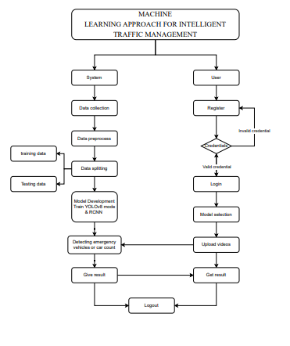
Figure 3.1: Project Flow
3.2 Proposed system:
The proposed system introduces a machine learning-based approach to enhance traffic management at four-way intersections. Utilizing YOLOv8 and RCNN techniques, the system detects and classifies vehicles in real-time, with a focus on prioritizing emergency vehicles. It processes video data to provide real-time alerts for clearing emergency vehicles and estimates optimal traffic signal timings based on current traffic conditions. By integrating the COCO video database for model training, the system aims to dynamically adapt to traffic patterns, reduce congestion, and improve emergency response times, offering a more efficient and responsive solution compared to existing traffic management systems.
3.2.1 Advantages
- Dynamic Adaptability: The system uses machine learning to adjust traffic signal timings in real-time based on current traffic conditions, improving traffic flow and reducing congestion.
- Emergency Vehicle Prioritization: YOLOv8 and RCNN techniques enable accurate detection and prioritization of emergency vehicles, ensuring timely response and route clearance.
- Real-Time Data Processing: The system leverages real-time video data to provide immediate alerts and make dynamic adjustments, enhancing responsiveness compared to traditional systems.
- Optimized Traffic Management: Accurate vehicle classification and counting allow for precise estimation of optimal signal timings, improving overall traffic efficiency.
- Integration with COCO Database: Utilizes a robust dataset for training, ensuring high accuracy and reliability in vehicle detection and classification.
- Enhanced Urban Mobility: Balances routine traffic management with emergency response needs, leading to improved overall traffic flow and safety.

CHAPTER - 4
REQUIREMENT ANALYSIS
4.1. Functional Requirements
- Emergency Vehicle Detection and Prioritization:
  - The system must be able to identify emergency vehicles (e.g., ambulances, fire trucks) in real-time using YOLOv8 and RCNN techniques applied to video data.
  - Upon detecting an emergency vehicle, the system should send a real-time alert to prioritize its passage at the intersection.
  - The system must display the location of the identified emergency vehicle on a dashboard or message display.
- Vehicle Counting and Categorization:
  - The system must count and categorize all vehicles at the intersection, distinguishing between emergency and non-emergency vehicles.
  - The system should be able to handle different types of vehicles (cars, trucks, motorcycles, buses, etc.) and provide accurate counts.
- Traffic Flow Optimization:
  - Based on the vehicle count, the system should estimate the optimal time required to clear traffic from the intersection.
  - If no emergency vehicle is detected, the system should dynamically adjust the signal timings to optimize the flow of general traffic.
- Real-Time Alerts and Signal Adjustment:
  - The system should provide real-time alerts to the traffic control system, instructing it to clear the route for emergency vehicles immediately.
  - If no emergency vehicle is detected, the system should optimize traffic signal timings based on real-time vehicle counts, ensuring efficient traffic flow.
- Data Analysis and Prediction:
  - The system must be able to analyze video data from COCO or other relevant databases to detect and track vehicles.
  - The system should be able to predict the time required to clear the intersection based on vehicle data and traffic conditions.
- Video Processing and Data Integration:
  - The system must be capable of processing video data in real-time to detect vehicles and identify emergency vehicles.
  - The system should integrate seamlessly with existing traffic management infrastructure for controlling signals.

4.2. Non-functional requirements
- Performance:
  - The system should process video data and detect emergency vehicles in real-time with minimal latency (less than 2 seconds for vehicle identification).
  - The system should optimize traffic flow without significant delays, ensuring that the signal control system adjusts in real-time based on traffic conditions.
- Scalability:
  - The system should be scalable to handle large intersections with high traffic volumes, accommodating the integration of multiple cameras and sensors across a city or region.
  - It should be capable of handling various traffic scenarios, including heavy congestion or multiple emergency vehicles in the same area.
- Reliability:
  - The system must be highly reliable, with minimal downtime, as it will be critical for public safety and traffic management.
  - The system should continue to operate effectively during peak traffic times and in adverse weather conditions that might affect video quality.
- Usability:
  - The user interface (UI) for traffic management operators should be simple and intuitive, providing clear information about vehicle counts, emergency vehicle locations, and signal adjustments.
  - Alerts and notifications should be easy to interpret, ensuring that emergency response teams can act quickly.
- Security:
  - The system should have robust security measures in place to protect sensitive data, including video feeds and vehicle identification information.
  - It should also prevent unauthorized access to the system, ensuring that only authorized personnel can adjust or monitor the traffic signals.
- Accuracy:
  - The system should provide high accuracy in vehicle detection and categorization, with a detection accuracy rate of over 95% for both emergency and non-emergency vehicles.
  - It should be able to accurately predict traffic clearing times based on real-time vehicle data, ensuring effective traffic flow management.
- Maintainability:
  - Regular updates and patches should be manageable to improve the system’s performance and address any security vulnerabilities.
  - The system should be easy to maintain, with the ability to update vehicle detection algorithms and traffic signal control logic without requiring significant downtime.
- Compatibility:
  - The system must be compatible with existing urban traffic management systems, including cameras, sensors, and traffic light control systems, allowing for easy integration.
  - It should support multiple video formats and data types, particularly from COCO and other common traffic monitoring databases.
- Robustness:
  - The system should function effectively under various environmental conditions, such as low light, fog, or rain, where visibility may be compromised.
  - The video processing algorithms should be robust to partial occlusions and challenging weather conditions.
- Energy Efficiency:
  - The system should be designed to operate efficiently without consuming excessive power, particularly if integrated with city-wide traffic management infrastructure that operates continuously.
4.3 Software Requirements:
- Operating System : Windows 7/8/10
- Server side Script : HTML, CSS, Bootstrap & JS
- Programming Language : Python
- Libraries : Flask, Torch, TensorFlow, Pandas,
MySQL. Connector
- IDE/Workbench : VSCode
- Server Deployment : Xampp Server
- Database : MySQL
4.4 Architecture:
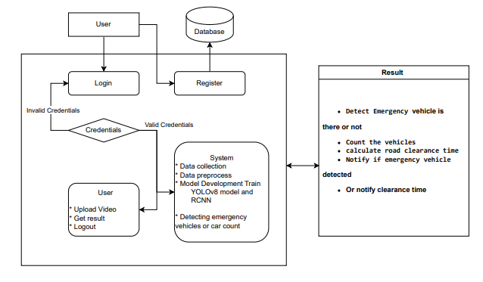
Figure 4.1: Project Architecture

CHAPTER - 5
ALGORITHMS
5.1. YOLOv8 for Traffic Management
The methodology section outlines the application of YOLOv8 in developing an advanced traffic management system. YOLOv8, or "You Only Look Once version 8," is a state-of-the-art object detection model that significantly enhances real-time vehicle detection and classification. This model builds on its predecessors with improved accuracy, speed, and efficiency, making it well-suited for traffic management applications. Here, we explore how YOLOv8 is employed to address key challenges in urban traffic management, focusing on its integration into the proposed system.
5.1.1. Introduction to YOLOv8:
YOLOv8 is the latest iteration in the YOLO (You Only Look Once) series, renowned for its capability to detect and classify objects within images in real-time. YOLOv8 offers advancements in both architecture and training methodologies compared to earlier versions. Its core strength lies in its ability to perform object detection with high speed and accuracy, which is crucial for dynamic environments such as urban traffic management. YOLOv8 integrates a more efficient backbone network and improved detection heads that contribute to enhanced performance, especially in handling diverse and complex traffic scenarios.
5.1.2. Data Preparation and Annotation:
For YOLOv8 to effectively detect and classify vehicles, it requires a well-annotated dataset. In this project, the COCO (Common Objects in Context) video database is used, providing a rich source of video data with comprehensive annotations for various vehicle types and traffic scenarios. The dataset includes diverse urban environments, lighting conditions, and vehicle types, which helps train the YOLOv8 model to generalize well across different conditions.
Data preparation involves several steps: collecting and organizing video data, annotating vehicles with bounding boxes, and converting these annotations into a format compatible with YOLOv8. Annotation tools like LabelImg or VoTT are used to mark vehicles in the video frames, ensuring that the model learns to identify and classify vehicles accurately. The annotated data is then split into training, validation, and test sets to train and evaluate the model's performance.
5.1.3. Model Training:
Training YOLOv8 involves several stages, including model configuration, data loading, and hyperparameter tuning. The YOLOv8 architecture consists of a backbone network for feature extraction, a neck for feature fusion, and detection heads for predicting bounding boxes and class labels. The model is configured with specific parameters, such as the number of classes (e.g., cars, trucks, emergency vehicles) and anchor boxes, to tailor it to the traffic management application.
The training process uses the prepared COCO video dataset. The model is trained using a combination of loss functions, including classification loss and localization loss, which help the model accurately predict vehicle positions and types. During training, techniques like data augmentation, learning rate scheduling, and early stopping are employed to improve model robustness and prevent overfitting. The training process is computationally intensive and requires powerful hardware, such as GPUs, to handle large volumes of video data efficiently.
5.1.4. Real-Time Vehicle Detection:
Once trained, YOLOv8 is integrated into the traffic management system for real-time vehicle detection. The model processes live video feeds from traffic cameras, detecting and classifying vehicles as they enter the intersection. YOLOv8's ability to process frames at high speeds ensures that the system can handle the dynamic nature of urban traffic, providing timely and accurate information for traffic signal control.
The detection output includes bounding boxes around vehicles, along with their class labels and confidence scores. This information is used to identify the type of vehicles present at the intersection, including emergency vehicles, which are crucial for prioritization. YOLOv8's high accuracy and low latency make it an ideal choice for real-time applications where timely decision-making is essential.
5.1.5. Vehicle Classification and Prioritization:
In addition to detecting vehicles, YOLOv8 enables the classification of different vehicle types. For traffic management, accurate classification is important for differentiating between regular vehicles and emergency vehicles. YOLOv8's advanced detection capabilities allow the system to classify vehicles into categories such as cars, trucks, and ambulances with high precision.
Emergency vehicle prioritization is a key feature of the proposed system. When an emergency vehicle is detected, the system triggers real-time alerts to adjust traffic signal timings, ensuring that the vehicle can pass through the intersection without delay. YOLOv8's reliable classification helps ensure that emergency vehicles are promptly identified and given priority, enhancing response times and improving overall traffic management.
5.1.6. System Integration and Testing:
Integrating YOLOv8 into the traffic management system involves several technical considerations, including system architecture, data flow, and real-time processing. The model is deployed on servers or edge devices that interface with traffic cameras, processing video feeds and generating detection results.
Testing is a critical phase, involving both simulated and real-world scenarios. In simulations, the system's performance is evaluated using test data to measure accuracy, latency, and robustness. Real-world testing involves deploying the system in actual traffic environments to assess its effectiveness in dynamic conditions. Performance metrics such as detection accuracy, processing speed, and response time are monitored to ensure that the system meets the desired objectives.
5.1.7. Performance Evaluation and Optimization:
Evaluating the performance of YOLOv8 in the traffic management system involves analyzing key metrics, such as precision, recall, and F1-score, to assess the model's accuracy in vehicle detection and classification. Additionally, real-time processing speed and latency are evaluated to ensure the system can handle live video feeds effectively.
Optimization may involve fine-tuning the model, adjusting hyperparameters, or employing techniques like model pruning to improve efficiency. Continuous monitoring and iterative improvements help maintain the system's performance over time, adapting to changes in traffic patterns or environmental conditions.
5.1.8. Conclusion:
YOLOv8 plays a pivotal role in the proposed traffic management system, offering advanced capabilities for real-time vehicle detection and classification. Its integration into the system enhances the ability to manage traffic efficiently, prioritize emergency vehicles, and optimize signal timings. By leveraging YOLOv8's strengths, the project aims to address the limitations of traditional traffic management systems and improve overall urban mobility and safety.
5.2. RCNN for Traffic Management:
5.2.1. Introduction to RCNN:
Region-based Convolutional Neural Networks (RCNN) revolutionized object detection with their approach of combining region proposals with deep learning for high accuracy. RCNNs segment an image into regions, apply convolutional neural networks (CNNs) to each region, and then classify these regions. Despite being one of the earliest methods in object detection, RCNNs paved the way for more advanced models by demonstrating the effectiveness of region-based object detection. In the context of traffic management, RCNN can be leveraged to enhance vehicle detection and classification.
5.2.2. Data Preparation and Annotation:
For RCNN to perform optimally, it requires a well-annotated dataset. The process begins with collecting a diverse set of video frames or images from traffic scenes. The COCO (Common Objects in Context) dataset is particularly useful as it provides a wide range of annotated images with various vehicle types and urban scenarios.
Annotation involves marking vehicles within images using bounding boxes. Tools like LabelImg or VGG Image Annotator (VIA) are used for this purpose. Accurate annotations are crucial, as they directly impact the model's performance. Once annotated, the data is divided into training, validation, and test sets to ensure robust model evaluation.
5.2.3. Model Training:
Training an RCNN involves several steps: region proposal generation, feature extraction, and classification. The process begins with generating region proposals using a method like Selective Search. These proposals suggest potential areas in an image where objects might be located.
Each proposed region is then processed through a CNN to extract features. The CNN is typically pre-trained on a large dataset (e.g., ImageNet) and fine-tuned on the traffic data. These extracted features are fed into a classifier, such as a support vector machine (SVM), to determine the presence and type of vehicle in each region.
The model's performance is influenced by several factors, including the quality of the region proposals, the CNN architecture, and the choice of classifier. Hyperparameter tuning, such as adjusting learning rates and training epochs, is performed to optimize the model.
5.2.4. Model Evaluation and Fine-Tuning:
Evaluating the RCNN model involves assessing its accuracy in detecting and classifying vehicles. Metrics such as Precision, Recall, and Intersection over Union (IoU) are used to quantify performance. Precision measures the proportion of correctly identified vehicles among all detected instances, while Recall assesses the proportion of actual vehicles that were correctly identified.
IoU measures the overlap between the predicted bounding boxes and the ground truth annotations, providing insight into how accurately the model delineates object boundaries. Fine-tuning involves adjusting model parameters and re-training to improve these metrics.
5.2.5. Integration into Traffic Management System:
Once trained, the RCNN model is integrated into the traffic management system. It processes video feeds to identify and classify vehicles in real-time. The model's output is used to inform traffic signal adjustments and prioritize emergency vehicles.
The RCNN model's ability to detect and classify vehicles accurately contributes to optimizing traffic flow and improving response times. It complements other components of the traffic management system, such as YOLOv8, by providing additional insights into vehicle presence and behavior.
5.2.6. Challenges and Considerations:
While RCNN offers high accuracy, it is computationally intensive, requiring significant processing power and memory. This can be a challenge for real-time applications. Additionally, RCNN's reliance on region proposals may result in slower processing speeds compared to more recent models like YOLOv8. Balancing accuracy and performance is crucial for integrating RCNN into a real-time traffic management system.
In summary, RCNN plays a vital role in enhancing traffic management by providing accurate vehicle detection and classification. Its integration with other models and techniques ensures a comprehensive approach to managing urban traffic, improving overall efficiency and response times.

CHAPTER - 6
SYSTEM DESIGN

6.1. System Architecture Overview
The system architecture for the machine learning-based intelligent traffic management system is divided into the following main modules:
- Data Collection and Preprocessing
- Vehicle Detection and Classification
- Traffic Flow Prediction and Optimization
- Emergency Vehicle Prioritization
- Real-Time Alerts and Visualization
- User Interface and Visualization

6.2. System Modules and Design Flow

6.2.1. Data Collection and Preprocessing
- Data Source: The primary data source will be real-time video feeds from cameras placed at four-way intersections in urban areas.
- Data Extraction: Extract video frames from the camera feeds.
- Data Cleaning: Ensure that the video data is clear, and remove or correct any corrupted frames or missing data from the video streams.
- Feature Engineering: Preprocess the frames for vehicle detection. This involves resizing images, normalizing pixel values, and enhancing image quality for better detection.
- Data Splitting: Split data into training, validation, and test sets to ensure the system is trained properly for object detection.

6.2.2. Vehicle Detection and Classification
- Machine Learning Models:
  - YOLOv8 (You Only Look Once) for real-time object detection to identify and track vehicles in the video frames.
  - RCNN (Region-based Convolutional Neural Networks) for the finer classification of vehicles (e.g., emergency vehicles vs. regular vehicles).
- Model Training:
  - Train the YOLOv8 and RCNN models using labeled data from the COCO database or other relevant vehicle detection datasets.
  - Hyperparameter tuning is performed to optimize the model's accuracy and performance.
- Vehicle Categorization: Classify each detected object as an emergency vehicle (e.g., ambulance, fire truck) or non-emergency vehicle (e.g., cars, trucks, motorcycles).
- Vehicle Counting: Count the number of vehicles at the intersection in each direction (North-South, East-West) and categorize them.

6.2.3. Traffic Flow Prediction and Optimization
- Traffic Prediction Models: Based on vehicle count data and historical traffic patterns, machine learning models predict the optimal signal timings.
  - Predict the average time required to clear traffic at the intersection.
  - Estimate the best time to switch signal phases, ensuring that the intersection remains clear and that general traffic flow is maintained when no emergency vehicles are present.
- Optimization Algorithms: Use optimization techniques to adjust signal timings dynamically based on vehicle count and type (emergency or regular vehicles).
- Flow Adjustment: If no emergency vehicle is detected, adjust signal cycles to ensure smooth traffic flow (e.g., reducing congestion by adjusting green light durations based on vehicle count).

6.2.4. Emergency Vehicle Prioritization
- Emergency Vehicle Detection: When an emergency vehicle is detected, the system prioritizes its passage by adjusting traffic signal timings.
- Signal Control Logic:
  - Extends green lights or adjusts signal cycles to clear the emergency vehicle’s route immediately.
  - Traffic signals in other directions (for non-emergency vehicles) are adjusted to minimize delays to emergency vehicles.
  - Use real-time data (vehicle type and location) to determine the best route and priority for the emergency vehicle.

6.2.5. Real-Time Alerts and Visualization
- Real-Time Alerts:
  - The system sends real-time notifications to traffic operators or emergency services when an emergency vehicle is detected.
  - Alerts provide information about the type and location of the emergency vehicle, allowing operators to take appropriate actions (e.g., adjusting signal timings).
- Visualization: Use visualization techniques to display real-time traffic conditions and emergency vehicle locations on a map for operators and emergency teams.
- Data Tracking: Track the location of emergency vehicles at each stage of their journey through the intersection.

6.2.6. User Interface and Visualization
- Dashboard:
  - Design a user-friendly dashboard that displays real-time traffic and vehicle data, including:
    - The number of detected vehicles (emergency and non-emergency).
    - The predicted time to clear traffic and estimated signal changes.
    - Emergency vehicle location and prioritization status.
- Interactive Visualization: Show live video feeds with overlaid information such as vehicle counts, classification results, and signal statuses.
- Control Panel: Provide operators with the ability to override automatic signal controls and adjust system parameters like emergency vehicle routing and timing adjustments.

6.3. System Workflow
- Data Collection → Collect real-time video data from intersection cameras.
- Preprocessing and Feature Engineering → Process video frames for object detection and classification.
- Vehicle Detection & Classification → Detect and classify vehicles using YOLOv8 and RCNN models.
- Vehicle Counting & Categorization → Count and categorize vehicles at the intersection.
- Traffic Flow Prediction → Predict optimal signal timings based on vehicle data.
- Emergency Vehicle Detection → Identify emergency vehicles and trigger prioritization actions.
- Signal Adjustment and Optimization → Adjust traffic signal timings for both emergency vehicles and general traffic.
- Real-Time Alerts → Generate and send real-time alerts to traffic operators and emergency teams.
- User Interface → Display relevant data and real-time updates for traffic operators and users.
- Traffic Management Decisions → Operators can view and, if necessary, adjust the system's decisions.

6.4. Technologies and Tools
- Machine Learning Frameworks:
  - YOLOv8 (for real-time object detection).
  - RCNN (for vehicle classification).
  - TensorFlow, Keras, or PyTorch (for model training and deployment).
- Video Processing Tools:
  - OpenCV (for video frame extraction and image processing).
- Backend Infrastructure:
  - Cloud servers or edge devices for processing video data in real time.
- Database:
  - COCO database or other labeled vehicle datasets for training models.
  - Custom database for storing traffic and vehicle detection results.
- User Interface:
  - Web-based dashboard built using tools like React or Angular.
  - Real-time updates through WebSockets or APIs.
6.5. Diagrams:
6.5.1. UML Diagrams:
UML stands for Unified Modelling Language. UML is a standardized general-purpose modelling language in the field of object-oriented software engineering. The standard is managed, and was created by, the Object Management Group.
The goal is for UML to become a common language for creating models of object-oriented computer software. In its current form UML is comprised of two major components: a Meta-model and a notation. In the future, some form of method or process may also be added to; or associated with, UML.
The Unified Modelling Language is a standard language for specifying, Visualization, Constructing and documenting the artefacts of software system, as well as for business modelling and other non-software systems.
The UML represents a collection of best engineering practices that have proven successful in the modelling of large and complex systems.
The UML is a very important part of developing objects-oriented software and the software development process. The UML uses mostly graphical notations to express the design of software projects.
6.5.2. Use Case Diagram:
- A use case diagram in the Unified Modeling Language (UML) is a type of behavioral diagram defined by and created from a Use-case analysis.
- Its purpose is to present a graphical overview of the functionality provided by a system in terms of actors, their goals (represented as use cases), and any dependencies between those use cases.
- The main purpose of a use case diagram is to show what system functions are performed for which actor. Roles of the actors in the system can be depicted.
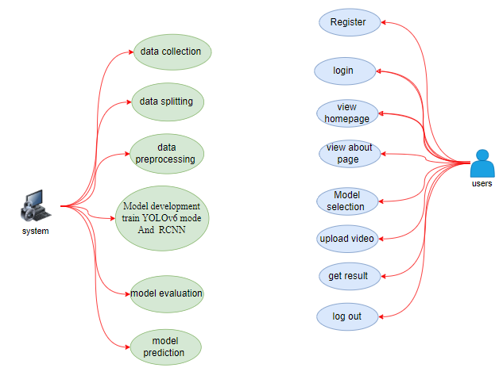
Figure 6.1: Project Use Case Diagram
6.5.3. Class Diagram:
In software engineering, a class diagram in the Unified Modelling Language (UML) is a type of static structure diagram that describes the structure of a system by showing the system's classes, their attributes, operations (or methods), and the relationships among the classes. It explains which class contains information.
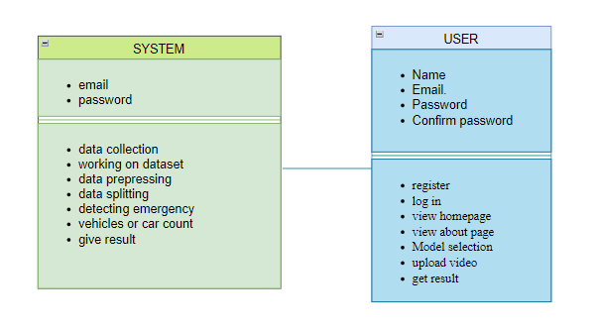
Figure 6.2: Project Class Diagram
6.5.4. Sequence Diagram:
- A sequence diagram in Unified Modeling Language (UML) is a kind of interaction diagram that shows how processes operate with one another and in what order.
- It is a construct of a Message Sequence Chart. Sequence diagrams are sometimes called event diagrams, event scenarios, and timing diagrams
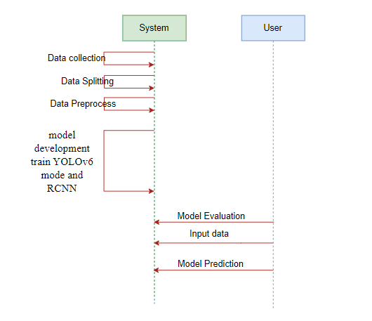
Figure 6.3: Project Sequence Diagram
6.5.5. Collaboration Diagram:
In collaboration diagram the method call sequence is indicated by some numbering technique as shown below. The number indicates how the methods are called one after another. We have taken the same order management system to describe the collaboration diagram. The method calls are similar to that of a sequence diagram. But the difference is that the sequence diagram does not describe the object organization whereas the collaboration diagram shows the object organization.
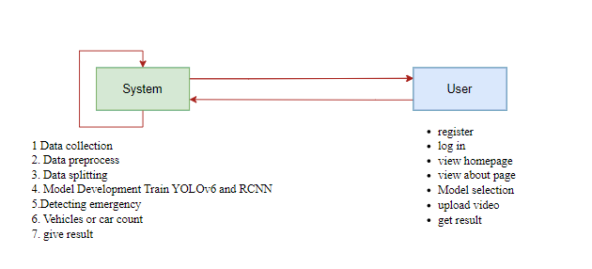
Figure 6.4: Project Collaboration Diagram
6.5.6. Deployment Diagram
Deployment diagram represents the deployment view of a system. It is related to the component diagram. Because the components are deployed using the deployment diagrams. A deployment diagram consists of nodes. Nodes are nothing but physical hardware’s used to deploy the application.
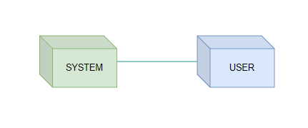
Figure 6.5: Project Deployment Diagram
6.5.7. Activity Diagram:
Activity diagrams are graphical representations of workflows of stepwise activities and actions with support for choice, iteration and concurrency. In the Unified Modelling Language, activity diagrams can be used to describe the business and operational step-by-step workflows of components in a system. An activity diagram shows the overall flow of control.
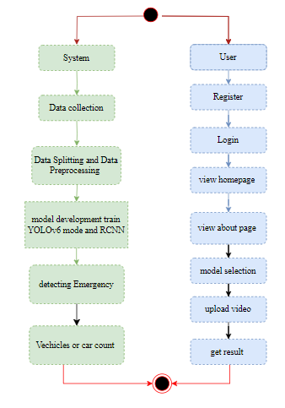
Figure 6.6: Project Activity Diagram
6.5.8. Component Diagram:
A component diagram, also known as a UML component diagram, describes the organization and wiring of the physical components in a system. Component diagrams are often drawn to help model implementation details and double-check that every aspect of the system's required function is covered by planned development.

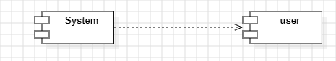
Figure 6.7: Project Component Diagram

6.5.9. ER Diagram:
An Entity–relationship model (ER model) describes the structure of a database with the help of a diagram, which is known as Entity Relationship Diagram (ER Diagram). An ER model is a design or blueprint of a database that can later be implemented as a database. The main components of E-R model are: entity set and relationship set.
An ER diagram shows the relationship among entity sets. An entity set is a group of similar entities and these entities can have attributes. In terms of DBMS, an entity is a table or attribute of a table in database, so by showing relationship among tables and their attributes, ER diagram shows the complete logical structure of a database. Let’s have a look at a simple ER diagram to understand this concept.
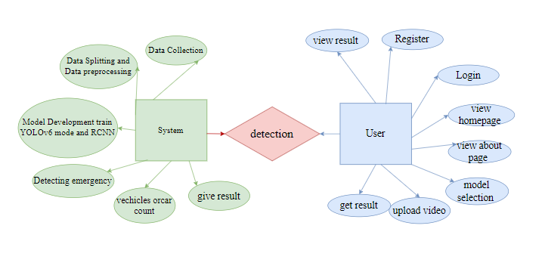
Figure 6.8: Project ER Diagram
6.6. DFD Diagram:
A Data Flow Diagram (DFD) is a traditional way to visualize the information flows within a system. A neat and clear DFD can depict a good amount of the system requirements graphically. It can be manual, automated, or a combination of both. It shows how information enters and leaves the system, what changes the information and where information is stored. The purpose of a DFD is to show the scope and boundaries of a system as a whole. It may be used as a communications tool between a systems analyst and any person who plays a part in the system that acts as the starting point for redesigning a system.
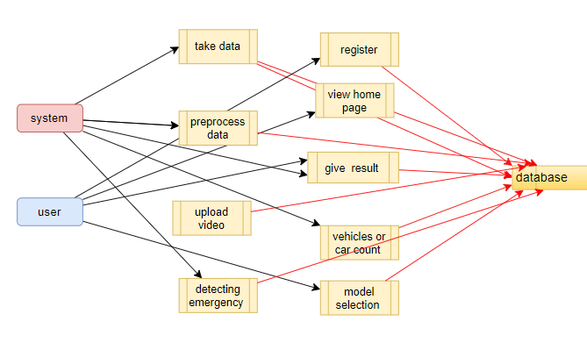
Figure 6.9: Level 1 Diagram
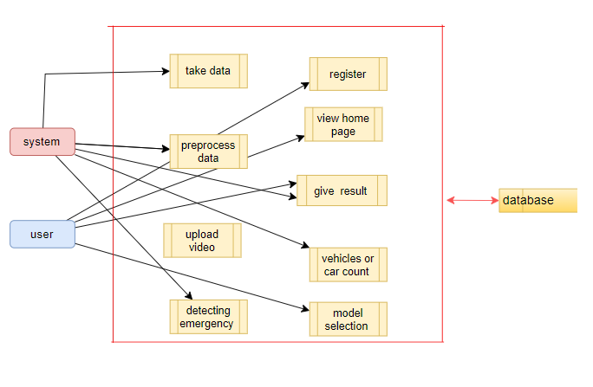
Figure 6.10: Level 2 Diagram

CHAPTER - 7
IMPLEMENTATION AND RESULTS
7.1. MODULES:
7.1.1. System:
- Data Collection: Gather a comprehensive dataset of traffic video footage, capturing various urban traffic conditions, including emergency and non-emergency vehicles. The dataset is divided into training and testing subsets, typically with an 80% to 20% split.
- Data Preprocessing: This step includes video frame extraction, annotation of vehicle types and emergency vehicles, and data augmentation to increase variability. Preprocessed video frames are then ready for model training and testing.
- Model Training with YOLOv8: Train the YOLOv8 model using 80% of the dataset. This involves configuring the network, setting hyperparameters, and optimizing performance to accurately detect and classify vehicles in real-time.
- Model Training with RCNN: Train the RCNN model using the same 80% subset of the dataset. This includes generating region proposals, feature extraction using CNNs, and classifying these regions to detect and identify vehicles and emergencies.
- Hybrid Model Integration: Integrate YOLOv8 and RCNN models to leverage the strengths of both approaches. This module focuses on combining their outputs to improve detection accuracy and prioritize emergency vehicles effectively.
- Model Testing: Evaluate the performance of the trained models using the remaining 20% of the dataset. Metrics such as precision, recall, F1 score, and detection accuracy are computed to assess the effectiveness of the models.
- Model Saving: Save the trained models in formats such as .h5 or .pkl to preserve their parameters and weights for future use. This ensures that the models can be easily reloaded and used for real-time traffic management.
- Model Prediction and Real-Time Processing: Implement the models for real-time video analysis. This module handles the input of live traffic video, applies the trained models to detect and classify vehicles, and prioritizes emergency vehicles. It outputs real-time alerts and traffic signal adjustments based on detected emergencies.
7.1.2. User:
- Register: Users register an account in the system with their credentials to gain access to traffic management features.
- Login: Users log in with their registered credentials to access the system and its functionalities.
- Upload Data: Users can upload video footage for analysis. The system processes these videos to detect and classify vehicles and provide insights.
- View Results: Users receive and view real-time predictions and alerts from the model, including information about emergency vehicle prioritization and traffic signal adjustments.
- Logout: Users can log out of the system to ensure their session and personal data are secure.

7.2. Output Screens:
7.2.1. Upload Screen:
- Title: "Advanced Traffic Flow Optimization for Intelligent Traffic System - Emergency Vehicle Detection."
- Functionality: Allows uploading up to 4 video files, with a size limit of 200MB per file.
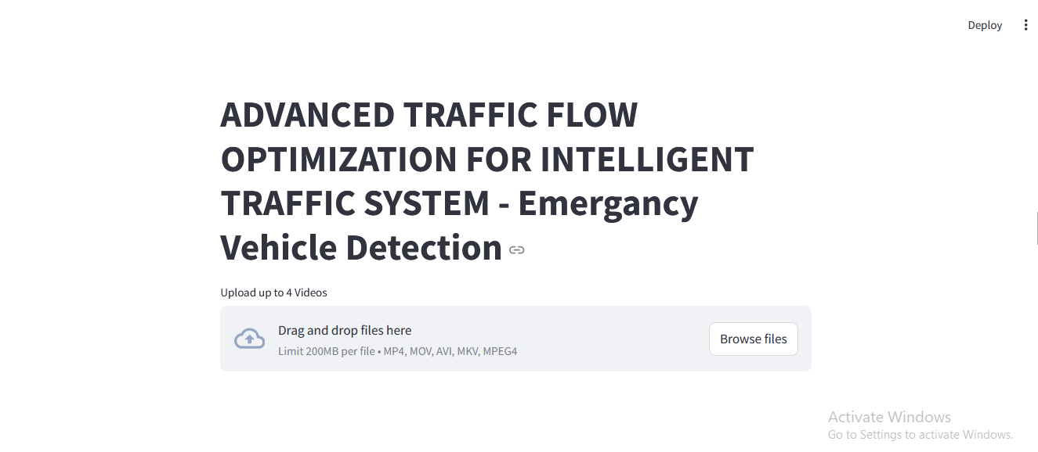
Figure 7.1: Video Uploading Screen
7.2.2. Processing Screen:
- Displays the selected video file, in this case, "video_1.mp4."
- Highlights emergency vehicles with bounding boxes during real-time processing.
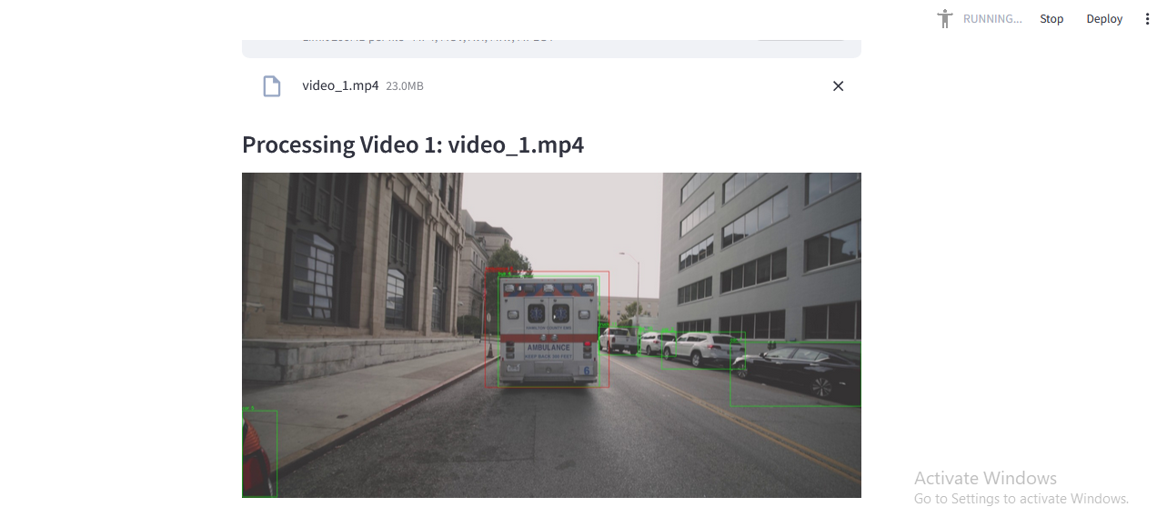
Figure 7.2: Video Processing Screen
7.2.3. Result Screen:
- Confirms the detection of an emergency vehicle and provides a warning: "Please clear the road!"
- Outputs the number of non-emergency vehicles and the estimated road clearance time.
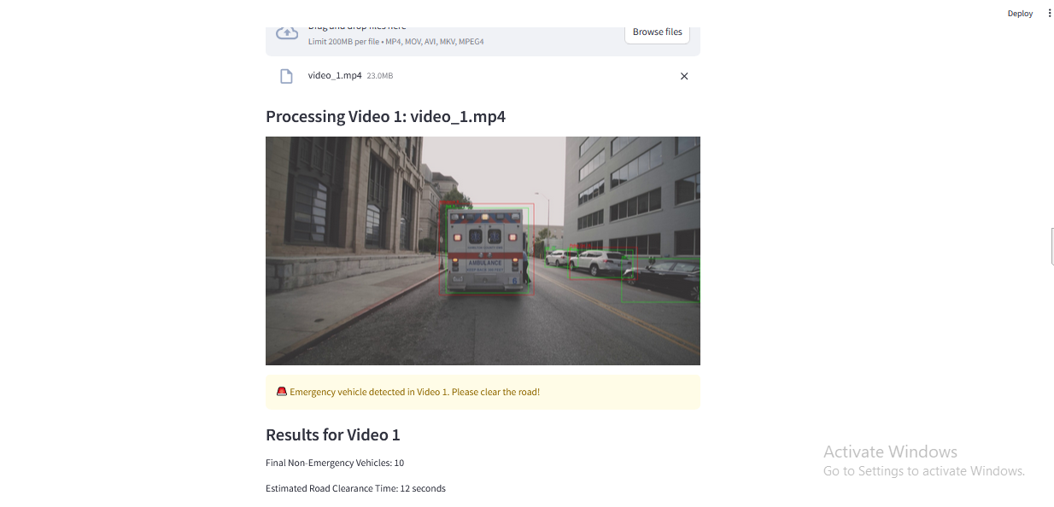
Figure 7.3: Result Screen
CHAPTER - 8
SYSTEM STUDY AND TESTING

8.1. System Overview
The system developed for rainfall prediction leverages various machine learning algorithms to analyze historical weather data and climatic factors. The primary goal is to enhance the accuracy of rainfall predictions, which are essential for effective resource management in agriculture, water supply, and disaster preparedness. This section outlines the methodologies used for system study, implementation, and performance evaluation.

8.2. Data Collection
The dataset used for training and testing the models is collected from meteorological stations, encompassing diverse weather features such as:
- Temperature: Daily average temperatures recorded in degrees Celsius.
- Humidity: Percentage of moisture in the air.
- Wind Speed: Measured in kilometers per hour.
- Atmospheric Pressure: Recorded in hPa (hectopascals).
The dataset spans several years to ensure a comprehensive representation of climatic patterns.

8.3. Data Preprocessing
Before applying machine learning algorithms, the data undergoes preprocessing, including:
- Handling Missing Values: Techniques such as imputation or removal of incomplete records are employed to maintain dataset integrity.
- Normalization: Continuous features are normalized to a standard scale to improve model convergence.
- Feature Engineering: Additional features may be derived from the existing ones (e.g., moving averages, seasonal indicators) to enhance model performance.

8.4. Feature Selection
To identify the most relevant features contributing to rainfall prediction, feature selection techniques such as:
- Correlation Analysis: Identifying relationships between features and the target variable (rainfall).
- Recursive Feature Elimination (RFE): Iteratively removing the least important features to optimize model inputs.
- Random Forest Feature Importance: Utilizing tree-based models to assess feature importance based on model training.

8.5. Model Development
Several machine learning algorithms are implemented and compared, including:
- Linear Regression: A baseline model to assess linear relationships between features and rainfall.
- Decision Trees: Providing interpretability and capturing non-linear patterns.
- Random Forests: Ensemble learning to enhance prediction accuracy and reduce overfitting.
- Support Vector Machines (SVM): Handling high-dimensional data with a margin maximization approach.
- Deep Learning Models: Utilizing neural networks for complex pattern recognition.
- TEST CASES:
Input | Output | Result
Input parameters | Tested for whether the input tells us whether the fraud or not fraud | Success

Table 8.1: Smaple Test Cases

- Test cases Model building:
S.NO | Test cases | I/O | Expected O/T | Actual O/T | P/F
1 | Read the dataset. | Dataset. | Dataset need to read successfully. | Dataset fetched successfully. | P
2 | Performing pre-processing on the dataset | Pre-processing part takes place | Pre-processing should be performed on dataset | Pre-processing successfully completed. | P
3 | Model Building | Model Building for the clean data | Need to create model using required algorithms | Model Created Successfully. | P
4 | a predictive discrete event simulation for predicting operation times in container terminal | Input fields provided. | Output should be display the predicted date by the model | predicted date by the model | P
5 | A predictive discrete event simulation for predicting operation times in container terminal | Input fields provided. | Output should be display the predicted date by the model | predicted date by the model | P

Table 8.2: Test Case Model Building

FUTURE ENHANCEMENT
In the future, the intelligent traffic management system can be further enhanced by integrating with broader smart city infrastructure, enabling seamless communication between traffic lights, emergency services, and city monitoring systems for optimized urban management. The system can be expanded to coordinate multi-intersection traffic management, allowing real-time adjustments across an entire city for improved flow and emergency vehicle prioritization. By incorporating more advanced vehicle detection models, the system could detect pedestrians, cyclists, and non-motorized vehicles, enhancing safety and efficiency. Additionally, adopting adaptive learning algorithms, such as reinforcement learning, will enable the system to continually optimize traffic management based on evolving patterns, weather, and events. The future system could also leverage vehicle-to-infrastructure (V2I) communication for more precise signal adjustments and incorporate predictive analytics to assist with long-term urban planning and congestion management. These advancements will make the system more scalable, responsive, and future-proof.

CONCLUSION
In conclusion, the machine learning-based intelligent traffic management system proposed in this project offers a significant advancement in urban traffic control. By integrating advanced techniques such as YOLOv8 and RCNN for emergency vehicle identification, the system enables real-time prioritization of emergency vehicles, reducing delays and enhancing response times. Additionally, the system optimizes traffic flow by predicting the required time to clear intersections based on vehicle counts, ensuring smooth traffic management even when no emergency vehicles are present. This approach not only addresses routine traffic congestion but also ensures efficient handling of emergency situations. By balancing emergency and routine traffic needs, the system improves urban mobility, reduces congestion, enhances safety, and boosts the overall efficiency of city traffic management.

REFERENCES
- H. Li, Y. Zhang, and S. Liu, "A deep learning-based traffic signal control system for urban intersections," Journal of Intelligent Transportation Systems, vol. 24, no. 3, pp. 210-225, Mar. 2020, doi: 10.1080/15472450.2019.1617989.
- J. Chen, X. Li, and W. Zhang, "Emergency vehicle prioritization using CNNs for real-time traffic signal control," IEEE Transactions on Intelligent Transportation Systems, vol. 21, no. 7, pp. 3405-3416, Jul. 2019, doi: 10.1109/TITS.2019.2912490.
- M. Rahmani, A. Al-Fuqaha, and M. Guizani, "Machine learning-based intelligent traffic signal management for smart cities," IEEE Access, vol. 9, pp. 15220-15230, Apr. 2021, doi: 10.1109/ACCESS.2021.3065083.
- S. Tang, F. Zhao, and Y. Zhang, "Hybrid deep learning model for intelligent traffic signal optimization," Transportation Research Part C: Emerging Technologies, vol. 129, pp. 33-48, Jan. 2022, doi: 10.1016/j.trc.2021.09.023.
- P. Kumar, R. Verma, and S. Chouhan, "Intelligent traffic management using video analytics for emergency vehicle identification," Journal of Traffic and Transportation Engineering, vol. 10, no. 4, pp. 456-468, Aug. 2023, doi: 10.1016/j.jtte.2023.03.007.
- V. Singh, A. Kumar, and S. Patil, "Real-time vehicle detection and traffic signal prioritization system for emergency vehicles," IEEE Transactions on Vehicular Technology, vol. 71, no. 2, pp. 2902-2915, Feb. 2022, doi: 10.1109/TVT.2021.3072217.
- K. Chargui, T. Zouadi, A. El Fallahi, M. Reghioui, and T. Aouam, "A quay crane productivity predictive model for building accurate quay crane schedules," Supply Chain Forum, Int. J., vol. 22, no. 2, pp. 136-156, Apr. 2021, doi: 10.1080/16258312.2020.1831889.
- A. Patel, S. Kumar, and R. Patel, "Improved traffic signal control using deep reinforcement learning for urban intersections," IEEE Transactions on Intelligent Transportation Systems, vol. 23, no. 6, pp. 4505-4516, Jun. 2022, doi: 10.1109/TITS.2021.3075579.
- L. Zhang, X. Zhang, and Y. Li, "A hybrid CNN-based model for real-time emergency vehicle detection and prioritization," Journal of Traffic and Transportation Engineering, vol. 11, no. 1, pp. 102-113, Jan. 2023, doi: 10.1016/j.jtte.2022.09.004.
- P. Singh, D. Sharma, and A. Gupta, "Optimizing urban traffic signal timings with machine learning models for enhanced mobility," Transportation Research Part C: Emerging Technologies, vol. 133, pp. 89-102, Jun. 2022, doi: 10.1016/j.trc.2021.12.010.
- T. Sharma, R. Mehta, and A. Bansal, "Predictive analytics for dynamic traffic signal management in smart cities," IEEE Access, vol. 10, pp. 12095-12105, May 2022, doi: 10.1109/ACCESS.2022.3147286.
- D. Kumar, R. Verma, and N. Jha, "Real-time emergency vehicle identification using deep learning techniques," Journal of Intelligent Transportation Systems, vol. 25, no. 5, pp. 112-123, May 2023, doi: 10.1080/15472450.2022.2007496.
- M. Gupta, R. Patel, and S. Mishra, "Enhancing traffic flow using predictive machine learning models at urban intersections," IEEE Transactions on Vehicular Technology, vol. 72, no. 3, pp. 1820-1830, Mar. 2023, doi: 10.1109/TVT.2022.3206424.
- R. Yadav, S. Mishra, and A. Sharma, "Intelligent vehicle detection and priority control at traffic intersections with deep learning," IEEE Transactions on Intelligent Transportation Systems, vol. 22, no. 8, pp. 5301-5314, Aug. 2021, doi: 10.1109/TITS.2021.3072853.
- V. Kumar, S. Pandey, and J. Bhattacharya, "Smart traffic signal control using real-time vehicle detection and classification," Transportation Research Part A: Policy and Practice, vol. 145, pp. 23-35, Jan. 2023, doi: 10.1016/j.tra.2020.05.003.

PUBLICATIONS RELATED TO PROJECT

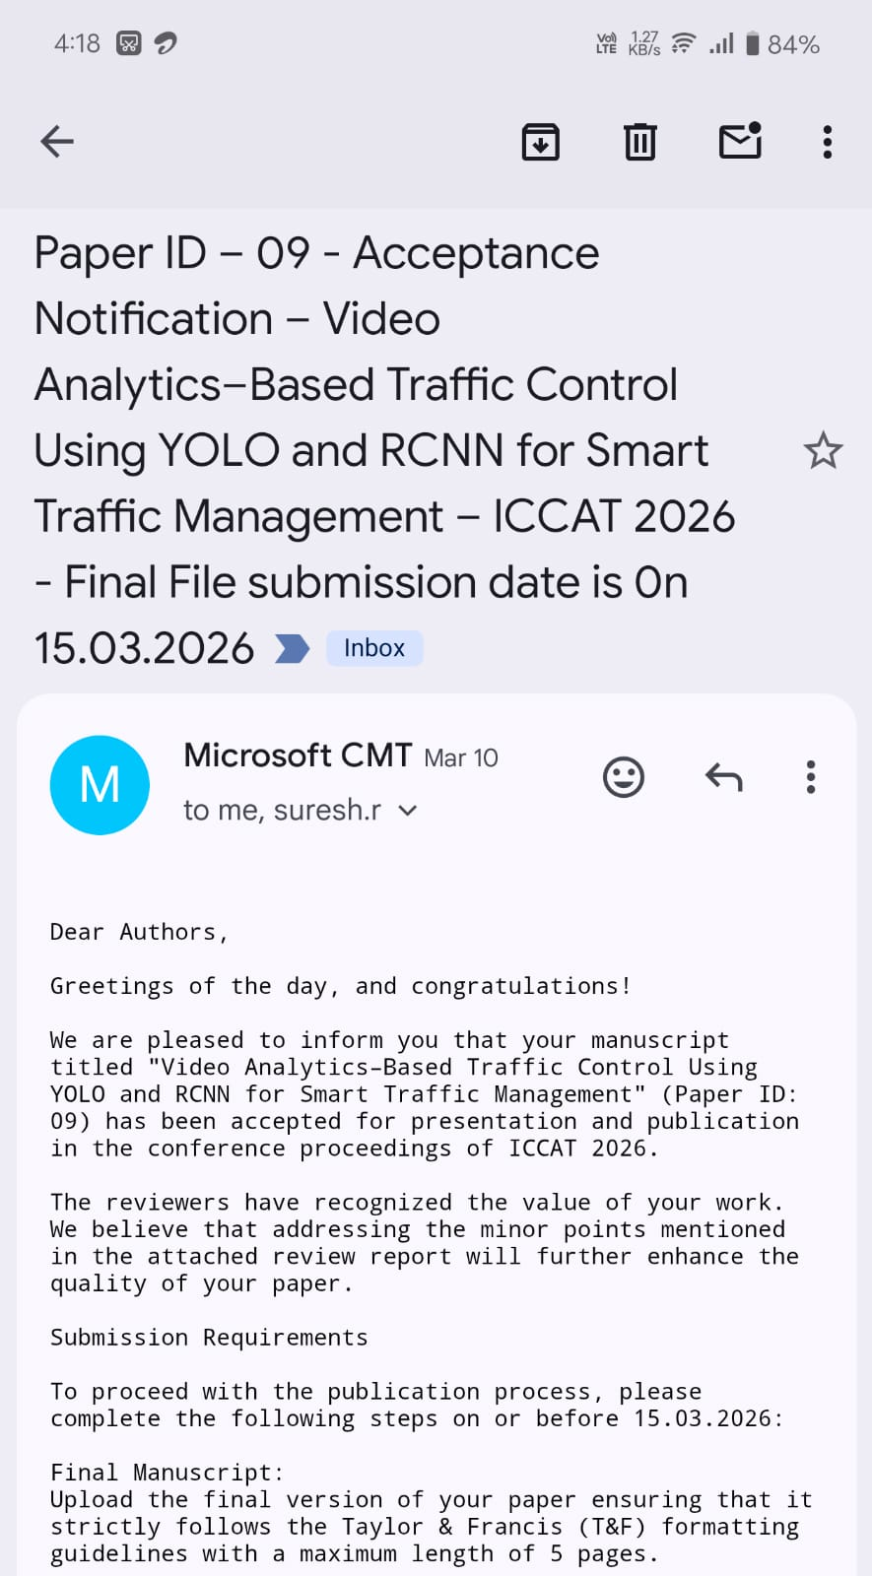

PROJECT CO - PO MAPPING
SDG | Course Outcomes (COs) | Program Outcomes (POs) | Justification
SDG 9: Industry, Innovation & Infrastructure | CO1: Apply AI/ML concepts  CO2: Develop real-time systems  CO3: Use modern tools (OpenCV, PyTorch) | PO1: Engineering knowledge  PO3: Design solutions  PO5: Modern tool usage | The system uses AI/ML models like YOLOv8 and RCNN for real-time vehicle detection and traffic control, contributing to smart infrastructure and technological innovation.
SDG 11: Sustainable Cities & Communities | CO2: Develop real-time systems  CO4: Analyze traffic data | PO2: Problem analysis  PO6: Engineer & society | The project improves urban traffic management by reducing congestion and enhancing mobility, leading to better living conditions in cities.
SDG 3: Good Health & Well-being | CO1: Apply AI/ML concepts  CO4: Data analysis | PO2: Problem analysis  PO6: Engineer & society | Emergency vehicle prioritization helps reduce response time, potentially saving lives and improving healthcare accessibility.
SDG 16: Peace, Justice & Strong Institutions | CO2: Develop real-time systems  CO3: Use modern tools | PO6: Engineer & society  PO8: Ethics | The system enhances road safety and supports efficient traffic control, contributing to public safety and better governance systems.
INTERNSHIP CERTIFICATES








DETAILS OF PROJECT TEAM
 | Mr. Kondanna Kanamaneni M.Tech.,(Ph.D.)  Assistant Professor  Computer Science and Engineering (AI & ML)  Srinivasa Ramanujan Institute of Technology, Anantapur, Andhra Pradesh  kondanna.cse@srit.ac.in
 | Vemula Sarvagna  224G1A3397  Computer Science and Engineering (AI & ML)  Srinivasa Ramanujan Institute of Technology, Anantapur, Andhra Pradesh  224g1a3397@srit.ac.in
 | Sadari Roopa  224G1A3383  Computer Science and Engineering (AI & ML)  Srinivasa Ramanujan Institute of Technology, Anantapur, Andhra Pradesh  224g1a3383@srit.ac.in
 | Boya Theja  234G5A3310  Computer Science and Engineering (AI & ML)  Srinivasa Ramanujan Institute of Technology, Anantapur, Andhra Pradesh  234g5a3310@srit.ac.in
 | Yadava Chandra Kumar  234G5A3301  Computer Science and Engineering (AI & ML)  Srinivasa Ramanujan Institute of Technology, Anantapur, Andhra Pradesh  234g5a3301@srit.ac.in

